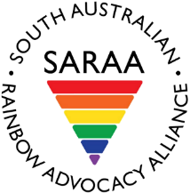
South Australian Rainbow Advocacy Alliance
PO Box 3438
Port Adelaide SA 5015
chairsaraa@gmail.com | www.saraa.org.au
www.facebook.com/southaustralianrainbowadvocacyalliance

20 November 2018

Committee Secretary
Senate Legal and Constitutional Affairs Committee
PO Box 6100
Parliament House
Canberra ACT 2600
legcon.sen@aph.gov.au

To whom it may concern

Re: Legislative exemptions that allow faith-based educational institutions to discriminate against students, teachers and staff

The South Australian Rainbow Advocacy Alliance (SARAA) is a not for profit incorporated association, we advocate for the health and human rights of LGBTIQ+ people in South Australia. We seek to create positive change to policy, legislation and systems affecting the ability of LGBTIQ+ people to live safe, happy and fulfilling lives in the wider community.
SARAA strongly contends that discrimination in any form is unwelcome in our society. We do not support any exemptions on religious grounds that would allow faith-based educational institutions to discriminate against students, teachers and staff on the grounds of sexual orientation or gender identity.
SARAA is particularly concerned that any legislative amendments to the Sex Discrimination Act (SDA) might further entrench or broaden the scope of exemptions for religious institutions. It is our understanding that some of the proposed amendments to the SDA as they currently stand would do exactly that.
The amendments should simply:
• repeal subsection 38(3) of the SDA; and
• amend section 37 to clarify that subsection 37(1)(d) does not apply to the treatment of students by religious schools.
Please find attached as appendix to this letter, the submission that SARAA prepared in response to the Religious Freedom Inquiry earlier this year. Herein you will find further detail regarding SARAA’s position and points in relation to religious discrimination against LGBTIQ+ communities in Australia.

Yours sincerely
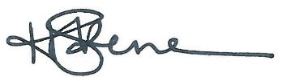
Holley Skene
Chair, SARAA Board

